ECEN 449 - 504

Lab 9 Report

William Liu

**Purpose:** The purpose of this lab is to demonstrate how modules can be included and start up during the boot phase of Linux on the Zybo board.

**Procedure:**

1. Create a folder in the drivers folder of the linux source code called “multiplier_driver”. Transfer the source code for the multiplier into this folder.
2. Create a ‘Makefile’ in this directory and add: obj-$(CONFIG_MULTIPLIER_DRIVER) += multiplier.o
3. Create a ‘Kconfig’ file the same directory and add:
   1. config MULTIPLIER_DRIVER

tristate “multiplier_driver”

depends on ARM

default y if ARM

help

refer to ECEN449@TAMU

4) Find the Makefile under the device drivers directory and add the following line to it

#ECEN 449

obj-$(CONFIG_MULTIPLEIR_DRIVER) += multiplier_driver/

5) Find the Kconfig file under the device drivers directory and add the following lines before ‘endmenu’:

Source “drivers/multiplier_driver/Kconfig”

6) Run the following command under the linux source directory:

Make ARCH=arm menuconfig

Verify that the multiplier driver is included under the device drivers directory

7) Compile Linux and generate the uImage.

8) Use BOOT.bin and devicetree.dtb from Lab 5 to boot Linux.

9) To add the ir_demod driver, follow the same steps from 1 to 6. BOOT.bin and devicetree.dtb must be modified to include both the multiplier and ir_demod.

10) To compare sizes of uImage, after verifying that multiplier and ir_demod start up correctly, remove Networking support, Multimedia support, and Soundcard support.

11) compare the sizes of uImage.

**Results:**

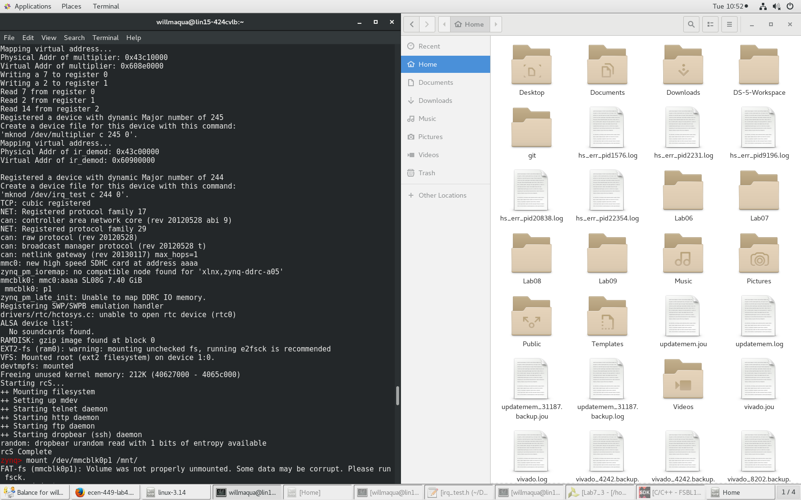

Output of boot startup with ir_demod and multiplier output included

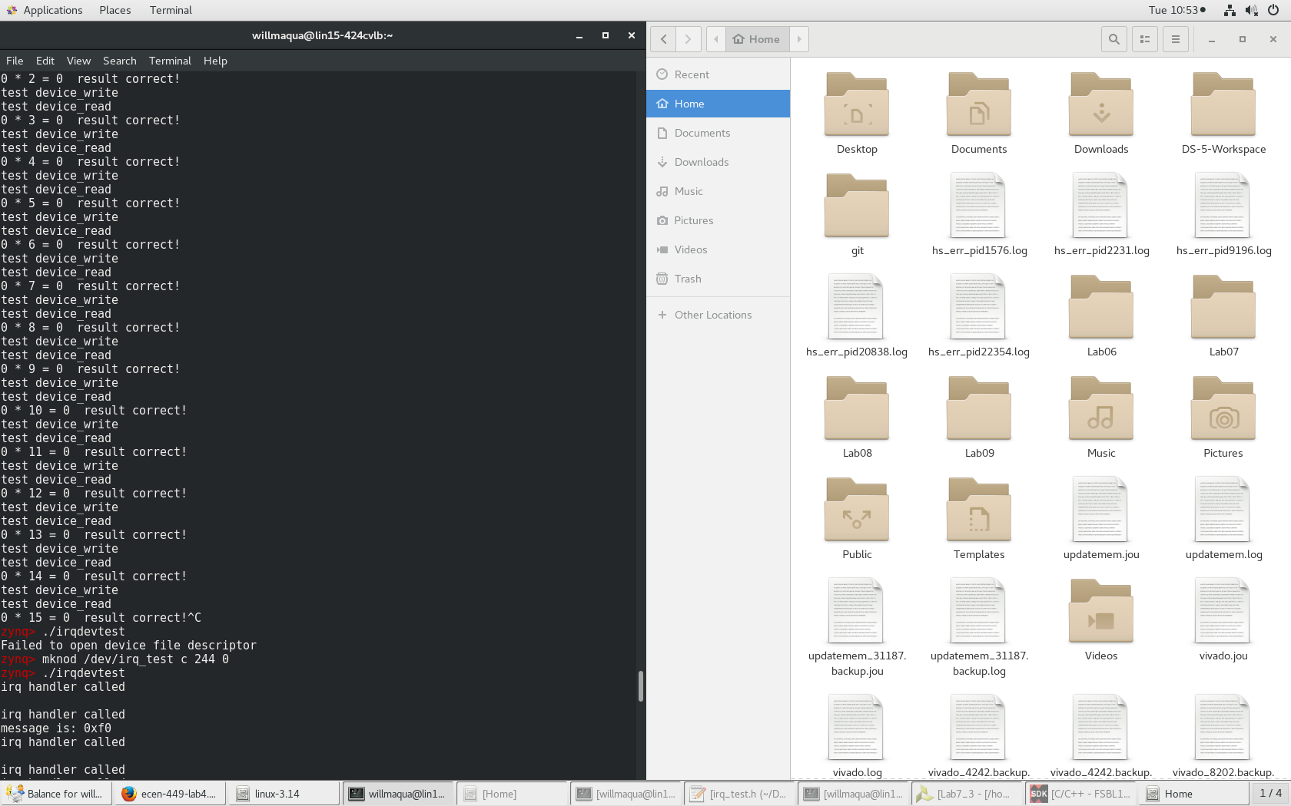

Output of both programs running after using the ‘mknod’ command

**Conclusion:**

By compiling the modules into the source code of Linux, the user does not have to run ‘insmod’ everytime to run their program. The programs will initiate during the startup routine and what's left to get the program running is to run ‘mknod’ and the respective executable. The uImage of the Linux system with only the multiplier driver is 3.4 MB while the uImage of the Linux system with the multiplier driver and the ir_demod driver is 3.5 MB. The uImage file of the Linux system without network, multimedia, and sound support is 2.5 MB; the smallest of all 3 files.

**Questions:**

**What are the advantages and disadvantages of loadable kernel modules and built in kernel modules?**

Loadable kernel modules are not included in the Linux source code so the total file size of the Linux image can be kept smaller. The downside is that in order to run the module, the user has to ‘insmod’, ‘mknod’, then run the executable. This is inefficient if the user has to run the module everytime he/she uses the system. Built in modules are the opposite; the user does not have to run ‘insmod’ to run the module everytime on startup, but at the cost of increased Linux image size.